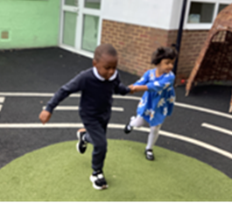
EYFS Spring Newsletter 2024
Our topic this term is “Actions”.

Communication: In communication sessions we have started to think about action words and have been doing lots of activities based on an action such as building. We are continuing to use photographs and symbols for the children to request activities and resources.
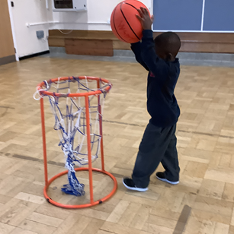
Physical development: During PE lessons we are continuing to use a range of different equipment and apparatus and are working on children taking turns and using photographs and symbols to request a turn on favourite equipment. We are also using music to learn about different movements and actions that we can use our bodies for, such as running, jumping and sleeping.

Personal, social and emotional development: Our morning choosing sessions allow children to have more free choice in the toys and activities they take part in and they are supported to develop more independent play skills through the adult modelling how resources can be used. Children are also being encouraged to be as independent as possible by taking their chairs to the table and walking between rooms at school with less adult support. We continue to learn about our emotions through our Zones of Regulation sessions.

Literacy: We are reading “Number 1, tickle your tum’ and focusing on the different actions that occur throughout the story. In our writing sessions we will be mark making in a variety of ways e.g. in sand, on whiteboards and using the touch-screen on the computer. We will also be watching as the initial letters of our names are written during every day routines and learning how to say the sounds the letters make.
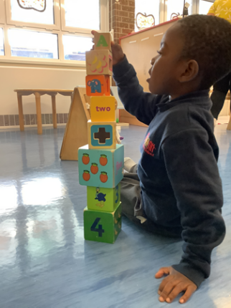
Mathematics: During number sessions we will be focusing on actions and choosing how many actions we want to do eg stamping on sand pies, clapping foam, throwing water balloons and squashing playdough balls. In shape, space and measures sessions we are learning about big and little, with the children choosing which size container, filled with different exciting objects and media, they want to explore.

Understanding the World: This term we will begin our community outings we will be going on different types of walks such as listening or textured walks, going to the park to explore different actions on the equipment or to the shops to buy ingredients for cooking. In ICT we will continue to learn to play games on the Interactive White Board and operate toys using switches.

Expressive arts and design: In our music sessions we are choosing our favourite action songs from ‘Singing Hands’ and using lots of instruments and props for the children to act out the songs. In Art we are exploring different ways to use tools and actions to create our art.

We are looking forward to events like Chinese New Year, our Valentines Disco and Easter.

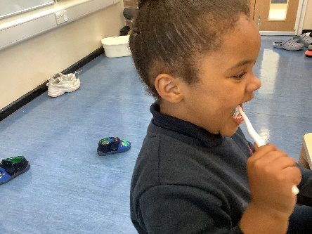
Many thanks
The Reception Team

