Home Learning Resources For:
At Red Gates we want to help support you during this time. Here are a range of useful resources so that you can continue your child’s learning while at home.
Class teachers remain contactable via class email addresses over the period of school closures (unless they become unwell). Should you require any specific symbols or signs during this time we are able to make those and send them across via email as well.
Photos of any work or activities done at home can be sent into the class email address with a description and uploaded by teachers onto Solar to contribute towards your child’s learning targets for the year. This helps us both show generalisation of learning and allows you be an active participant in your child’s education.
Your teacher’s class email address is:

The Solar web address is: https://redgates.solarforschools.org.uk/login
Should you need to reset your password simply click the ‘Forgot your password’ link on the login screen and follow the steps indicated.
The email address we have linked to your SOLAR account is:

Learning songs, signs and Stories
Singing Hands:
Enjoy Singing and learning to sign along to a wide range of songs with your child.
Find Me at:
https://www.youtube.com/user/SingingHandsUK
Barefoot Books:
Enjoy a wide range of sing along stories with engaging illustrations.
Find Me at:
https://www.youtube.com/user/barefootbooks
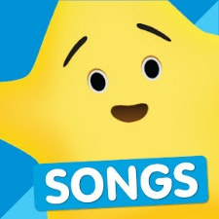
Super Simple Songs:
A collection of traditional nursery rhymes as well as traditional children’s songs to sing with you kids.
Find me at:
https://www.youtube.com/user/SuperSimpleSongs
Mr.Tumble:
Join Mr.Tumble and friends exploring the world, specially made for children with learning difficulties the show uses Makaton signing and is a great resource for learning new signs and simple songs.
Find me at: Search Something Special on Youtube or type in
https://www.youtube.com/channel/UCynLtJ9E2c34bui4ON0ovGw
Singing Walrus:
Interactive and easy to sing along to songs written by teachers and professional muscians
Find me at:
https://www.youtube.com/user/SingingWalrusMusic
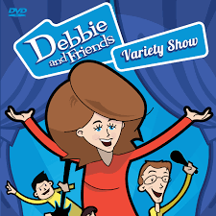
Debbie and Friends:
Sing-a-long songs and fairytales
Find me at:
https://www.youtube.com/user/debbiecavalier

Get active

Koo Koo Kangaroo:
Get active and follow along to simple action songs.
Find me at:
https://www.youtube.com/user/kookookangaroo

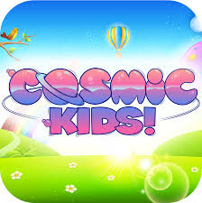
Cosmic Kids:
A range of Yoga and Mindfulness activities specially designed to do with children.
Find me at:
https://www.youtube.com/user/CosmicKidsYoga

The Learning Station:
Nursery Rhymes, Songs and lots of Dance-a-long fun.
Find me at: https://www.youtube.com/user/TheLearningStation

English, maths and science resources
TopMarks:
A wide range of activities and games to support maths skills and English including counting and sequencing, phonics and writing. Some activities are tablet friendly and are indicated as such.
Find me at:
Once you in the main page select the Learning games tab and navigate from there.
https://www.topmarks.co.uk/
Starfall:
A wide range of tracing sheets, games and online learning to support English and Maths skills
Find me at:
starfall.com
Science Bob:
Fun and effective science experiments that you can do with your kids.
Find me at:
https://sciencebob.com/
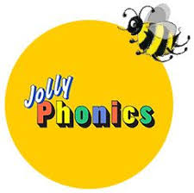
Jolly Phonics:
Teach initial sounds using simple action songs
Find me at: (search Jolly phonics on YouTube or type in)
https://www.youtube.com/watch?v=U2HYM9VXz9k

Education.com:
Online educational games and worksheets
Find me at:
https://www.education.com/games

Help Kidz learn:
Range of communication apps, social stories and learning games for SEN children. We use their products in school and they have released a range of products for free during school closures.
Find me at:
https://www.helpkidzlearn.com/updates/school-closure.html
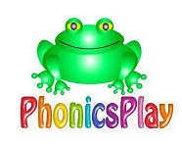
Phonics Play:
Phonics games, resources and printables. They have provided a free username and password for parents to use during the shutdown.
Find me at:
https://www.phonicsplay.co.uk/

Games and activities
CBeebies:
A wide range of games and activities centred around the CBeebies shows. Complete a puzzle, play a game or colour your favourite charactors.
Find me at:
https://www.bbc.co.uk/cbeebies
YouTube Kids:
Allows access to only content that is appropriate for children. Explore a wide range of songs and shows.
Find me at:
https://www.youtube.com/user/kookookangaroo
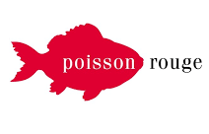
Poisson Rouge:
Flash based range of activities for computer or tablet, both free and subscription based.
Find me at:
https://www.poissonrouge.com/
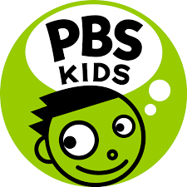
PBS Kids:
American website with online games covering a wide range of topics and characters
Find me at:
https://pbskids.org/games/

CBC Kids:
Canadian website with online games covering a wide range of topics and characters
Find me at:
https://www.cbc.ca/kidscbc2/games
Cartoon Network Games:
Online games featuring characters from the cartoon network, best for older children.
Find me at:
https://www.cartoonnetwork.co.uk/games

ideas and resources

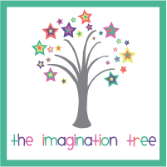
Poisson Rouge:
Activity based learning inspiration and recipes for a wide range of ages. They have a great playdough recipe that we use all of the time.
Find me at:
https://theimaginationtree.com/
Pinterest:
Activity search engine with links to a wide range of websites and blogs. Simply put in the terms of what you would like to look for i.e Sensory maths, playdough recipe, messy play, taste safe activities and then browse the results which are displayed through photo thumbnails
Find me at:
https://www.pinterest.co.uk/
Twinkl:
Usually a paid resource for teachers and home learners Twinkl are releasing some activities free of charge during this time. Click on Coronoavirus offer of help at the top of the website or access the Parents Hub.
Find me at:
twinkle.co.uk/resources/parents
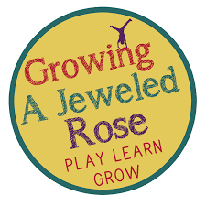
Growing a jeweled rose:
Play based and sensory learning activities based seasons, holidays and sensory media.
Find me at:
https://www.growingajeweledrose.com/
Learning 4 Kids:
Fun and simple ideas to promote creative play and learning. Easy to navigate based on categories such as fine motor, sensory, shape etc.
Find me at:
https://www.learning4kids.net/
Teachers Pet:
Thousands of teaching resources and pintables
Find me at:
https://tpet.co.uk/

Teach Starter:
Primary resources, there are several free ones available.
Find me at:
https://www.teachstarter.com/

Tacpac
Tacpac is a way of developing communication through touch and music. We’ve included two sessions below for you, simply line up all the songs listed on Youtube and make your way through the playlist. Work on a soft surface (blanket or mat) on the floor.
Pupils should work one to one with an adult as far as possible. Start the music and change activity each time you hear the music change. Try not to talk, other than responding to your child. Interact with them and be led by their responses to the activities and stimuli. Record interesting, unusual or new responses and interactions.
Visit https://tacpac.co.uk for more information.
Tac pac handy pack:
- Tap with the pads of your fingers, keep rhythm with the music (‘Tubular Bells part 2 Sailors Hornpipe’ (original edit) Mike Oldfield)
- Cascade with your fingers down the body, in time with the music. Pause in between movements (‘Top of The World’ The Carpenters)
- Lightly snatch with soft flat fingers, pulling away quickly and firmly (‘Dance of the Sugar Plum Fairy’ Tchaikovsky)
- Squeeze firmly in sequence along the arms and legs (‘The Cross of Changes’ Enigma)
- Draw squares all over the body with your finger (‘Feeling Groovy’ Simon and Garfunkel )
- Draw circles all over the body with your finger (‘Suo-gan’ Aled Jones)
- Massage with fingertips, using oil or lotion (‘Sailing’ Christopher Cross)
- Relax, wrap yourselves in blanket and listen to the music (‘Find My Way Home’ Jon and Vangelis)

Tac pac Morning:
Track 1: Nina Simone – I’m Feelin’ Good
Body brush or hands giving long smooth strokes down body, arms and legs.
Track 2: Rag’n’bone Man – I’m only Human
Lightly snatch with soft flat fingers, pulling away quickly and firmly
Track 3: Fridge – Harmonics
Taping with finger tips along to the music, increase pressure with intensity of song.
Track 4: Fleetwood Mac – The Chain
Squeeze firmly in sequence along the arms and legs
Track 5: Flute and Drumming
Closed finger tapping along with the rhythm
Track 6: Harry Styles – Ever since New York
Wafting a piece of fabric/sheet gently over child, pulling fabric through hands, running fabric over body.

Sensory recipes
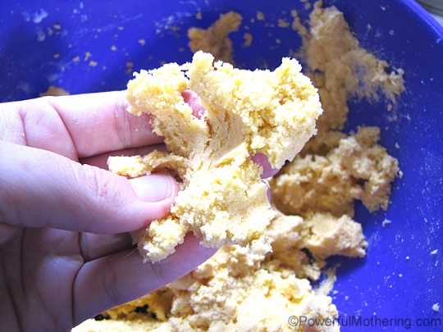
Taste Safe Foam Dough
- Whipping Cream
- Cornflour
- Food Colouring
Take whipping Cream and mix with an electric beater.
When stiff add cornflour bit by bit until it starts sticking to the beaters.
Add colouring
Play!

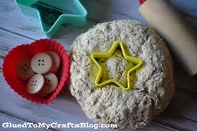
Oatmeal Playdough
- 2 parts uncooked oats
- 1 part water
- 1 part flour
- Any spices desired for scent
Combine ingredients into a bowl. Mix together.
When combined, kneed for several minutes until the right consistency forms.

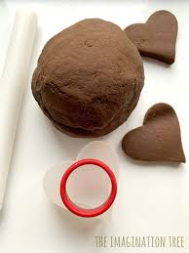
Chocolate Playdough
- 2 cups of all-purpose flour
- 1/2 cup of table salt
- 1/2 cup of cocoa
- 1 1/2 cups of boiling water
- 3 tablespoons of vegetable oil
- 1/2 teaspoon of vanilla (optional)

Put all ingredients into a large bowl. Mix well until a ball starts to form. Let cool for a few minutes and then dump it onto the counter and knead.
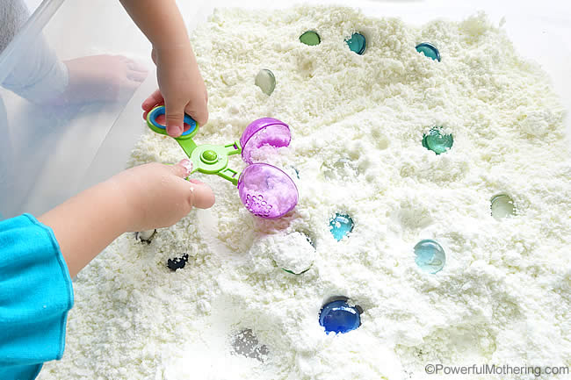
Taste Safe Snow Dough:
- 8 cups cornflour
- 1 cup olive oil
- Peppermint oil
Place all ingredients into a large Tupperware or bag. Shake and mix until fully combined.

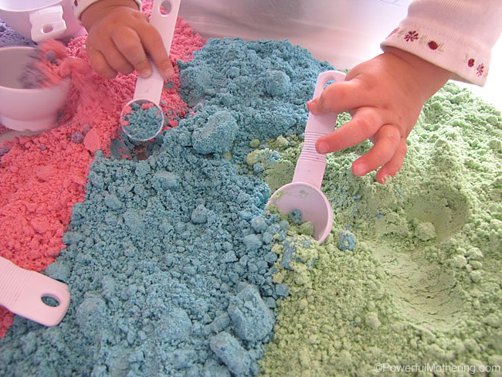
Taste safe cloud dough / moon sand
To make cloud dough mix in the 1:8 ratio. That is 1 cup of oil to 8 cups of flour.
You will need:
- 2 cups All purpose flour
- ¼ cup Vegetable oil
- Oil based food colouring or powder food colouring
- Spices of your choice for scent
- a bowl for mixing
- a sensory tub for playing in
Please use your kitchen measuring cups and don’t guesstimate or else your cloud dough recipe will be too wet. Making the cloud dough is also very easy and does not take much time. A great plus! Store in a sealed container for several weeks.
How to colour cloud dough?
For the colouring you have two options. You can use powered colouring and mix it in the flour before adding the oil or you can use oil based food colouring and premix it in the oil before adding it to the flour.

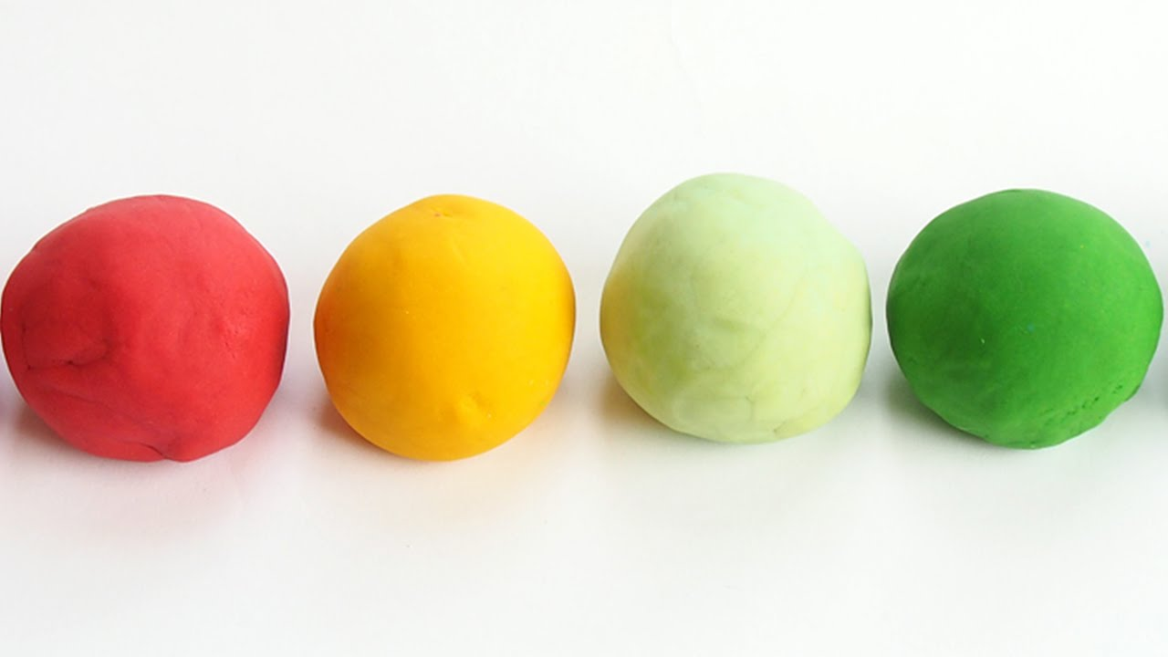Playdough Recipe
- 2 cups Flour
- 1 Cup Salt
- 2 Tbsp Veg oil
- 2 Tbsp Cream of Tarter
- 1 ½ Cups Boiled water
- Any additions wanted: food colouring, fragrance, glitter, spices etc.
Step One: Take a large bowl and add flour, salt, vegetable oil, and cream of tartar.
Step Two: add in any extras such as glitter, spices or fragrance.
Step Three: boil the kettle and pour 1 1/2 cups of the water into your mixture. Add in any food colouring at this stage so it mixes evenly through the dough.
Step Four: mix the ingredients together to form a dough and you are ready to play.
Play dough problems: solved
Play dough too crumbly? Add a little more oil.
Play dough too sticky? Add in a little more flour.
Want your play dough to last a long time? Wrap it up well in a plastic bag as soon as you’ve finished playing and your play dough could last for months.
* Not got all the ingredients? If you discover you have no cream of tartar, no problem – just leave it out. You can make a basic dough just by combining flour and water if that’s all you have. The dough won’t last but will give you a great day’s worth of play.

Mini water beads (Edible)
- 1 tablespoon basil or chia seeds
- 1 ¼ cup water
- Few drops of food colouring
Mix together and soak for 5 minutes stirring occasionally.
When ready to use add to tray with a bit more water.

Story massage
We all love stories. When combined with the benefits of simple massage strokes, stories present wonderful opportunities for creativity and interaction.
Story massage involves the use of easy-to-follow massage strokes associated with spoken words that help to build up an engaging story. The strokes concentrate on shoulders, back, arms and head. No oil is used and children do not remove any clothes.
Movements and stories can be adapted to suit the individual needs of children of varying ages, abilities, personalities and temperaments.
When sharing story massage you can choose positions that are the most comfortable and suitable for the situation. You can sit, lie down or stand, work one-on-one in a line or circle. Story massage is an activity to be enjoyed whenever or wherever the time feels right. The emphasis is on sharing the many benefits of nurturing and positive touch.
Please find attached instructions for the different strokes as well as a few stories to enjoy with your child.
You can also visit https://www.storymassage.co.uk/ for more information

