Play-based Home Learning Pack
All of the activities are accessible with simple items you may have at home. The purpose of these activities is to engage your child in play that you both can do together to make this time more enjoyable for all. Please encourage siblings and other family members to get involved in the fun, too, the more the merrier!
(**Any items you may need to gather for the activity are in bold font)
Indoor Activities and Games:
- Treasure Hunt- Hide favourite toys or items around the house for your child to find
- Kitchen Music- Take out pots, pans, plastic bowls/containers and allow your child to explore making different music with a wooden spoon. Prompting your child to listen to the sounds that the different objects make!
- Sock/Balloon Catch- Have a sock fight or engage your child in a game of catching and throwing using a bunched up pair of socks as a soft ball
- Sock Skittles- Set up plastic bottles as skittles and using a bundle of socks encourage your child to aim towards them to knock them down
- Balloon Keep-Away- Blow up a balloon and model keeping it off the ground and away from your child. Encourage them to try and get the balloon back and then you try and get it back again!
- Blanket Races- Encourage your child to sit on a blanket and hold on tight as you grab an end and pull them around for ride
- Catch the Bubble- Blow bubbles towards your child and prompt them to try and catch the bubbles in their hands before they pop
- Over the River- Put down cushions on the floor. Encourage your child to move around by stepping on the cushions only in order to avoid the rushing water below
- Make a Fort- Drape blankets over chairs or other furniture and create a tent or fort for you and your child to play in!
- Build a Tower- Using old cardboard boxes or plastic containers, make a tower with your child and see how high it will go before tumbling down
Outdoor Activities/Garden Games:
- It- Chase your child around the garden or outside area, tickling them when you get them. Encourage them to then come and chase you!
- Throwing and Catching- Use soft toys or a ball to practice catching and throwing
- Blanket Parachute- Using a blanket as a parachute, place soft toys or other items into the parachute and make them fly off
- Sponge Fight- On a hotter day, dip some sponges in water and have a sponge fight, the wetter the better!
- Minibeast Hunt- Encourage your child to help you look for different minibeasts
- Sound Safari- Go on a walk around the garden or the local neighbourhood and listen out for what sounds you can hear
- Sensory Scavenger Hunt- Go on a hunt around the garden or local neighbourhood for leaves, flowers, sticks, pebbles etc. and look at these items together
- Water Painting- Use old toothbrushes and/or paint brushes to make marks on the pavement using just water
- Fairy Soup- Assist your child in collecting items from the garden to place into a big bowl to make a fairy soup full of leaves, sticks, flowers, dirt etc.
- Stick Drawing- Prompt your child to collect a stick and encourage them to make marks with the stick in the dirt, making shapes and drawing lines
- Sensory Bottles- Prompt your child to collect various items from around the garden and place them into a container or plastic bottle
Sensory Tray Ideas:
- Goldilocks Porridge Exploration- wet or dry oats, big and little bowls, big and little spoons, teddies
- Jack and the Beanstalk- uncooked dry beans, sticks, leaves, containers to fill and empty
- Three Little Pigs- sticks, grass, plastic bricks, plastic pig animal toys
- Soapy Water Tray- use washing up liquid, shampoo or bubble bath in warm water to create a bubbly water mixture for your child to explore
- Cornflour Goop- mix cornflour and water to create a goopy-slime for children to explore using their hands or kitchen utensils
Interactive Music Sessions:
- https://www.soundabout.org.uk/tv/
- https://www.kellysurette.com/awesomeathomemusicactivitiesforyourchildwithspecialneeds.html#/
- Singing Hands- https://singinghands.co.uk/what-we-do/forthcoming-events/
Easy Recipe Ideas:
- Flapjacks- https://www.gousto.co.uk/blog/quick-easy-flapjacks-recipe
- Crispy Chocolate Squares- https://www.bbcgoodfood.com/recipes/crispy-chocolate-fridge-cake
- Baked Apples- https://www.bbcgoodfood.com/recipes/baked-apples
- Apple Crumble- https://www.allrecipes.com/recipe/241523/simple-flourless-apple-crisp/
- Banana Pancakes- https://tasty.co/recipe?0=%2Fhealthy-banana-pancakes&slug=healthy-banana-pancakes&canonicalUrl=https%3A%2F%2Ftasty.co
- Rainbow Toast- https://www.food.com/recipe/painted-toast-217200#activity-feed
- Pitta Pizzas- https://www.allrecipes.com/recipe/14584/veggie-pita-pizza/
- Fruit Salad- Using any fruits you have around the house, canned or fresh
- Chocolate Banana Smoothie- https://www.dropbox.com/sh/ta7p5n52q53ra8a/AAAMQ__NEDXkQXJkXq0O_lGIa?dl=0&preview=Smoothies.docx
Art Ideas:
- Rainbows- Using colouring pens/paint or bits of coloured paper assist your child in making a rainbow picture for the window to spread hope
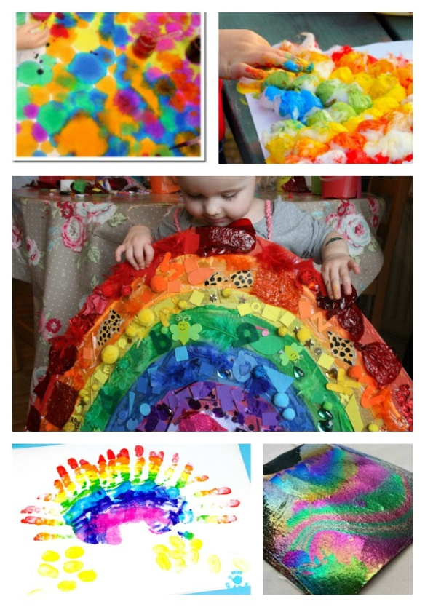

- Nature People- Using sticks and leaves from the local neighbourhood, encourage your child to using glue to stick them onto a template and create a nature creature!
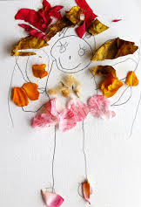
- Nature Crown- Collect leaves, sticks and flowers to stick onto a piece of paper using glue. Then wrap the piece of paper around your child’s head and tape it to create a crown
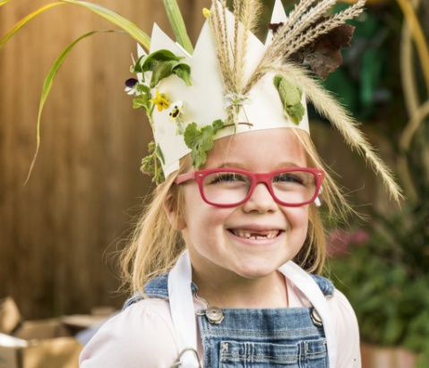

- Tracing Household Items- Model tracing simple items from around the house, encouraging your child to match the item to the tracing and then trace their own
- Mark-making- Provide your child with a colouring pen or pencil and provide them with some scrap paper to mark make on
- Chalk Pictures- On a nearby sidewalk, encourage your child to make marks on the sidewalk using chalk. Model drawing shapes and letters and prompt your child to trace them or make marks of their own
Relaxation and Quiet Time Ideas:
- Hand and foot massage with cream or with a few drops of calming essential oils
- Bubbles and calming music
- Deep pressure- You can give your child deep pressure massage, also known as deep pressure touch or “hand hugs.” This involves using the palms of your hands to apply firm pressure to the child's body, working from the hands and feet inward towards the torso
- Wafting a gentle fabric or scarf
- Share a simple story together, encouraging your child to look at the pictures and help turn the pages
- Singing your child’s favourite songs quietly together
Stories on YouTube:
- Dear Zoo https://www.youtube.com/watch?v=rudDGRQ9QGA

- Handa's Surprise https://www.youtube.com/watch?v=XyIV_xYi0as

- Monkey Puzzle https://www.youtube.com/watch?v=JxpJnk3QO-8

- Room on the Broom https://www.youtube.com/watch?v=jCnY5ju15oY

- Rosie's Walk https://www.youtube.com/watch?v=R3kNUTwJhf8

- The Gruffalo https://www.youtube.com/watch?v=s8sUPpPc8Ws

- The Tiger who Came to Tea https://www.youtube.com/watch?v=d_3a1dgigtw

- The Very Hungry Caterpillar https://www.youtube.com/watch?v=75NQK-Sm1YY

- There was an Old Lady who Swallowed a Fly https://www.youtube.com/watch?v=V80Mi6BQfb8

- We're Going on a Bear Hunt https://www.youtube.com/watch?v=0gyI6ykDwds

- Virtual Sensory Story- Sail Away https://creativemusicmind.com/all-at-sea/

- Summer Story- https://www.dropbox.com/sh/ta7p5n52q53ra8a/AAAMQ__NEDXkQXJkXq0O_lGIa?dl=0&preview=Summer+exploration.pptx#

- I Love Summer- Story Massage https://www.dropbox.com/sh/ta7p5n52q53ra8a/AAAMQ__NEDXkQXJkXq0O_lGIa?dl=0&preview=I+love+summer.docx

Daily Exercise Ideas:

Parachute songs/activities (use a blanket or a scarf if you do not have a parachute):
- https://www.youtube.com/watch?v=ysWLALtSlHc
- https://www.youtube.com/watch?v=jSW4mbqfCd8&list=PL4SXVOH1zcBFhzFMdYbaD0ubjqSqRD62B&index=2
- https://www.youtube.com/watch?v=OnEwCwtyEt8
Movement/ Exercises/Dance
- ‘Ready steady go’ https://www.youtube.com/watch?v=gFflzDaxfKM
- ‘The circle song’ https://www.youtube.com/watch?v=LaADmR92xOk
- ‘Shake and move’https://www.youtube.com/watch?v=I5RUzkySseE
- ‘Calming Exercises for Kids’ https://www.youtube.com/watch?v=cyvuaL_2avY
- ‘Jump’ https://www.youtube.com/watch?v=kcQJDpj5TSY
- ‘Exercise for children’ https://www.youtube.com/watch?v=-HLjxcrgiPg
- ‘Shake it Out Body Parts’ https://www.youtube.com/watch?v=1cqLp1RqHl8
- ‘ 5 minutes move’https://www.youtube.com/watch?v=d3LPrhI0v-w
- ‘5 Minute Move Featurin Betsy’https://www.youtube.com/watch?v=u0_1QBQ8Syk
- ‘Shake break’ https://www.youtube.com/watch?v=s-8CSs7XnIo
- ‘Twist’ https://www.youtube.com/watch?v=eiU7oJgktuo
- ‘Shake Your Sillies Out’https://www.youtube.com/watch?v=NwT5oX_mqS0
- ‘Let’s get fit. Count to 100’ https://www.youtube.com/watch?v=0TgLtF3PMOc
Additional Learning Content:
http://www.thesensoryprojects.co.uk/covid19-resources
https://www.facebook.com/CASPAOnline/
https://flamingochicks.org/athome/
http://frozenlighttheatre.com/wp-content/uploads/2020/04/Home-Sensory-resource-Kit.pdf
Further Learning on Play for Parents:
Intensive Interaction and its Importance: https://www.youtube.com/watch?v=rjKxu6QKjAo
Free Courses on Understanding Play:
The Role of Play in Children’s Learning:
https://www.open.edu/openlearn/education/professional-development-education/the-role-play-childrens-learning/content-section-0?active-tab=description-tab
Play, Learning and the Brain: https://www.open.edu/openlearn/education/educational-technology-and-practice/educational-practice/play-learning-and-the-brain/content-section-0?active-tab=description-tab

