Summer Holidays Six-Week Learning Pack - Sensory Pathway
Week One:
Theme: Under the Sea
Reading: ‘A Hole in the Bottom of the Sea’
- https://www.youtube.com/watch?v=R1Qn2bcZRTo
- Listen through the story with your child- do not hesitate to sing along!
- Prompt your child to clap or move along to the rhythm as they listen
Maths:
- Sing ‘1, 2, 3, 4, 5 Once I Caught a Fish Alive’ with your child. Focus on engaging with them in a way that they prefer and sing along together
- Treasure Hunt Sensory Tray- Create a simple treasure hunt activity with household items and shiny items that you can hide for your child to find
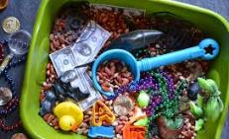
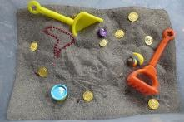

- Count the objects with your child as they find them
- Sort objects by colour, shape or category as they are found
- Prompt your child to say colours or shapes
Science:
Seaside Sensory Bottles
- Collect some empty plastic bottles of different sizes along with some tiny items that will fit inside e.g. glitter, sand, small shells or stones, tiny plastic fish etc.
- Prompt your child to choose what they would like to put inside, help them to post the items in
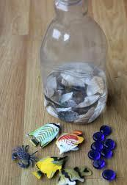
- Assist your child in filling the bottle about half-way full with water and adding in a few drops of blue food colouring
- Seal the bottle well with a thick tape
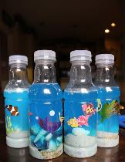
- Allow your child to explore their bottle!

Art:
Seaside Bubble Paintings
- Prompt your child to choose their paint colour and help you to mix the paint in a plastic cup with a little bit of water and a squirt of washing up liquid
- Provide your child with a straw that has a hole cut in it so that they cannot suck up the paint mixture
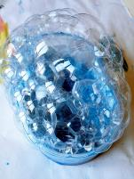
- Model blowing through to create bubbles, prompt your child to do the same until the bubbles overflow onto a piece of paper
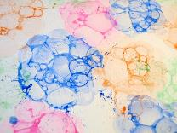

P.E.:
- ‘Popcorn the Dolphin’- A Cosmic Kids Yoga Adventure
- https://www.youtube.com/watch?v=YR1OxBk8BF4

Weekly recipe: Seaside Cupcakes
- https://theimaginationtree.com/beach-cupcake-recipe/
- Lead your child in making the cupcakes together, encouraging them to help mix, pour and spread the icing on afterwards!

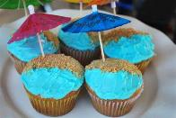

Week Two:
Theme: Things that Move!
Reading:
Stories and songs about transport on YouTube, listen through the stories and songs, sing along and encourage body movement to imitate the different things that move.
- We All Go Travelling By: https://www.youtube.com/watch?v=Kpoze1QKOCY&list=PL4-h6dy_PbjeTx2UoZT07cFim7kRmnnXA
- Driving my Tractor: https://www.youtube.com/watch?v=Lj_odhwo81s&list=PL4-h6dy_PbjeTx2UoZT07cFim7kRmnnXA&index=2
- Up, Up Up: https://www.youtube.com/watch?v=Lrd0TiER_J0&list=PL4-h6dy_PbjeTx2UoZT07cFim7kRmnnXA&index=5
- The Wheels on the Bus: https://www.youtube.com/watch?v=9siyDPch-6c&list=PL4-h6dy_PbjeTx2UoZT07cFim7kRmnnXA&index=6
- Space Song Rocket Ride: https://www.youtube.com/watch?v=SAHy_2IFFGA&list=PL4-h6dy_PbjeTx2UoZT07cFim7kRmnnXA&index=7
- Transport Adventure: https://www.youtube.com/watch?v=NOeV7t9O6iE&list=PL4-h6dy_PbjeTx2UoZT07cFim7kRmnnXA&index=10
Mark making and writing activities:
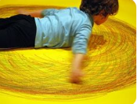
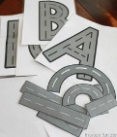
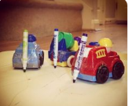
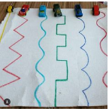

- Draw different line as shown in the picture, encourage and model tracing the lines with cars or other transport toys.
- Selotape markers or chalk to the back of the toy cars and let your child move the cars around and see what marks they make.
- This activity is good for gross motor skills if you have paper big enough or make a box flat or have an area of concrete. Encourage your child to make big lines and see how far they can stretch to make their marks. If you use different colours, it looks like a rainbow.
- Draw letter shapes, encourage and model tracing the letter shapes using toy cars or roll a ball over the shapes. Encourage your child to trace their name. Extend the activity by cutting out the long, short and curved shapes and make a road to trace over drive toy cars on

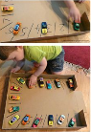
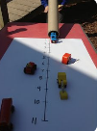
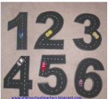
Maths:

- Sing some counting rhymes about transport (see attached rhymes at the end of this topic)
- Cut out number shapes and draw the road line markings along the centre. Encourage and model tracing the number shapes with cars, trucks, a ball or with just a finger.
- How far can your car go? Make a ramp using a piece of cardboard or a kitchen roll tube and mark out a number rhyme. Roll the car down the ramp and see how far they go. Whose will go the furthest?!
- Parking car/trucks. Use a box or paper or on the cornet with chalk, draw parking stations and number them. Encourage and model parking cars in order.
- Out for a walk? Count the cars, buses, trucks or planes you see. Ask questions like, ‘How many wheels? What colour? Do you think that car/truck/bus/plane goes fast or slow?’

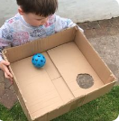
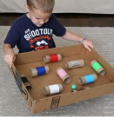
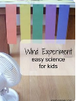
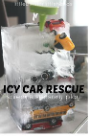
Science:

- Freeze some transport toys in an ice cream container and let your child rescue the cars using a squeezy bottle and water. You can also simply watch it melt in the sun, counting the toys as they are freed from the ice.
- In this exploration, children can watch thigs move using the power of a fan. Tie some ribbon to the fan shield or to the edge of the table, use material like ribbon, old cloth, paper and watch how they move differently as the fan is placed on different speeds.
- Make it move, using a box cut one hole, anywhere, the size of a ball or rolled up socks and show your child how to hold the box and move it to make the ball roll into the hole. More challenging, use toilet paper rolls to make tunnels encourage your child to navigate the ball through the tunnels before finding the hole.
- I love this one, it is so much fun! Using a balloon, selotape, a straw and a piece of string, you can make balloon rockets. Tie the string to a chair or a door handle, place the balloon on the straw like in the photo, blow up the balloon and let it go, see how fast it makes it to the other side of the room.
- Sensory trays let your children explore using their senses here are some images of ideas for what you can use in the sensory trays at home.
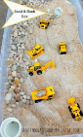
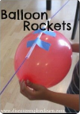
- Make a car wash, it’s so much fun and helps keep the toys clean
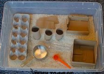
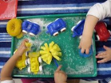

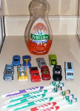

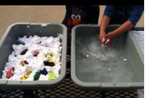

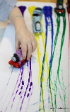
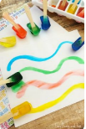
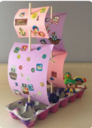
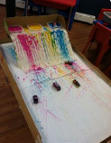
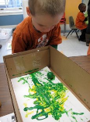
Art:

- Ball or marble art, use an old show box and a ball or marble. Place some paper at the bottom of the box add some paint, just a little, then encourage your child to hold the box moving it side to side, rocking it forward and backwards, making the ball move to roll through the paint.
- Painting with tires, using different types of transport toys show your child to dip the wheels in the paint and then drive them on the paper making patterns from the tires.
- Ice cube painting, freeze some food colouring in an ice cube tray and put either sticks or crayons in the water before freezing. Take them out and slide the ice across the paper or sit it in the sun and watch it melt.
- Design and make a pirate ship. Using resources around the house make different kinds of boats. Let’s see if they float, fill a bucket of water, or the bathtub, and place boats in the water, do they float?
P.E.:
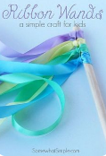
- Line up some cushions on the floor sit in front of each other and hold hands, pretend you are in a boat sing ‘Row, Row, Row Your Boat’ while rocking back and forward, rock side to side, be careful not to fall out or the crocodile might get you!
- Make your own dance ribbon. Tie some ribbon (or old cloth cut into strips) to a stick (find one in the garden) play some music and wave your ribbon round, try to make some shapes with your ribbon, big circles, little circles, can you wave it high can you make it wriggle on the floor?
- Making kites can be fun and easy this kite, guaranteed to fly. Colour some paper, cut out a beak and tail feathers. Take one corner and roll it over on an angle till it reaches the other side and selotape or staple it (just like in the picture). Near the beak make a hole and attach some string. Now run around with your hand held high and watch you bird kite fly behind you.
- Transport yoga poses for children https://www.youtube.com/watch?v=tRIngE1Xz80&list=PLRMST0orR7keCKxTC8LXeOGAuxRb9KEZ1
- Some action and dance songs for you to enjoy together
Encourage moving to the music and copying the actions.
https://www.youtube.com/watch?v=H6hkqdoZTqg
https://www.youtube.com/watch?v=fGEyttZb5Qk
https://www.youtube.com/watch?v=JoF_d5sgGgc
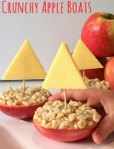
Weekly recipe: Apple Boats:
You will need: apples, peanut butter or Nutella (chocolate spread)/honey, some rice crispies (or you can use popcorn) a toothpick and some cheese
Cut the apple in half (de-core the apple), spread your chosen spread on the flat side of the half apple and dip it in the rice crispies
Cut the cheese into a triangle and poke one end of the toothpick into the cheese and one into the apple (shown in picture). You have your very own crunchy apple boat snack!
Below are some other healthy transport-themed snacks ideas you can make:
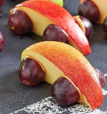
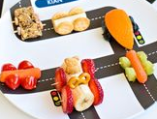
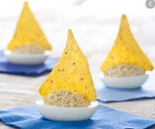
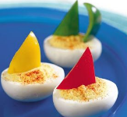

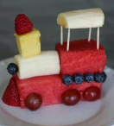

The Transportation Song

Take a bus 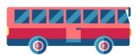
Or take a train
Take a boat
Or take a plane
Take a taxi
Take a car
Maybe near or maybe far
Take a rocket to the moon
But be sure to come back soon!
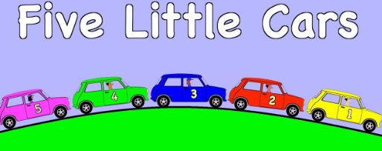
One little car,
Going to the zoo,
Met another car,
Then there were two

Two little cars
Driving by the sea,
One drove up from the beach,
Then there was three.

Three little cars
Driving by the shore,
Another pulled out,
Then there were four.

Four little cars
Out for a drive,
Another car joined them,
Then there were five.

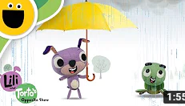
Week Three:
Go, Go, GO!

We can fly in a plane,
We can ride on a train,
In a boat, we will row,
We can go, go, go!

We go near, we go far,
In a bus or in a car,
We go high, we go low,
So, where should we go?
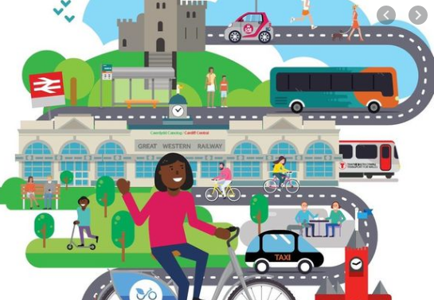
Theme: Wet and Dry
Reading:
- Lilli and Torto’s Opposites Show: ‘Wet and Dry’
https://www.youtube.com/watch?v=uW-ZJ07cJHU
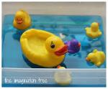
Maths:
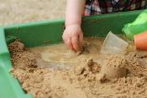

- 5 Little Ducks number song https://youtu.be/pZw9veQ76fo
- Get out a big pot or tray that you can fill with water (or during bath time) as you sing the song together you can make a splash as each duck swims away
- Sand/mud play. Use spoons, bowls and cups to explore quantity. Filling and emptying bowls and cups helps develop hand eye co-ordination. You can count how many scoops it takes to fill the bowl, build anticipation as you pour the sand out of the bowl from a height and develop understanding of ‘full’ and ‘empty’
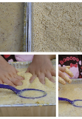
Science:
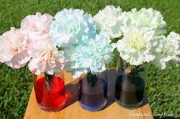
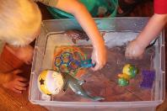

- How does water move? Using any white cut flowers place them into bottles or cups with food colouring added to the water (the more intense the colouring the better!) Over 24 hours you will see the flowers start to change colour as they drink the water in the cups!
- Sink and Float experiment. Using different toys and natural materials place them into the water to see if they sink or they float.
- Wet and Dry Sensory Play. Explore items such as oats, cornflour, rice, sand etc in a tray or bowl. Using a cup or bottle of water slowly add it in to make the mixture ‘wet’. How does it feel different to when it was dry? Your child may enjoy exploring one texture more than the other. Use bowls, spoons and cups to explore the mixture and notice how it moves differently when it is wet and when it is dry.

Art:
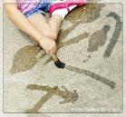
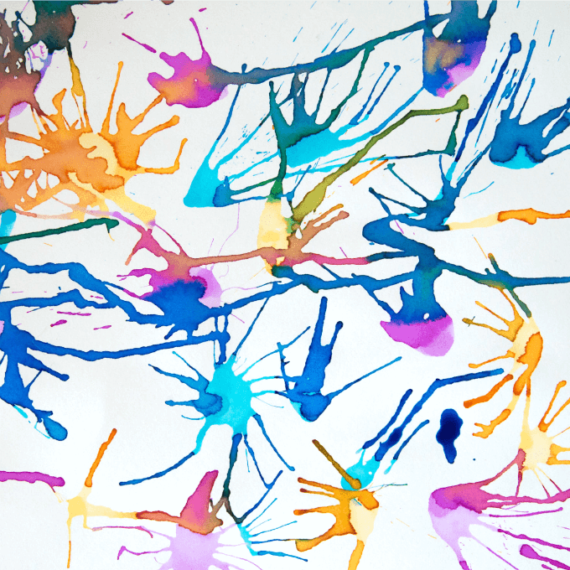

- Blow painting: Using a straw put drops of thinned paint onto some paper or cardboard. Encourage blowing through the straw to see how the paint moves across the surface. Blowing is a great activity for developing muscle control for your mouth. If your child has trouble blowing try tipping the paper back and forth after you have dropped the paint onto and watching how the paint runs over the surface
- A great no mess activity for a hot summer’s day! Use water and some old paintbrushes or rollers to ‘paint’ on the tarmac. Look at all the amazing lines and marks you can make as the surface changes colour

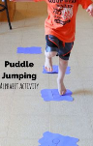
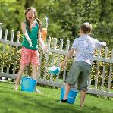
P.E.:

- Jumping puddles – Use old material or paper to make pretend puddles you can use letters and numbers on the puddles too
- Wet sponge catch – On a hot day use a wet sponge to develop gross motor skills and play catch with your child. You can also strengthen fingers by Squeezing the water out of the sponge (and maybe onto one another!)
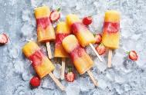
Weekly recipe:
Layered Iced Fruit Lollies:
- 400ml 100% pure orange juice smooth
- 8 small strawberries, sliced into 8 pieces
- 160ml 100% pressed forest fruits juice

- Line up 8 ice lolly moulds. Pour 2 tbsp orange juice into each. Put in the freezer for 1 hr.
- Divide the strawberries evenly between each mould. To get the fruit to show in the finished lollies, make sure you press the berries into the side of the moulds. Cover each one with 1 tbsp forest fruit juice. Leave to freeze for 30 mins, then push a lolly stick into each. Return to the freezer for 1 hr.
- Remove from the freezer and add 2 tbsp orange juice to each mould for the final layer. Return to the freezer for at least 2 hrs to make sure the lollies are fully set.
- Briefly dip the lolly mould in warm water to release the ice. Eat straight away.
Tip: It's easy to change the flavours: simply swap the juice to your preferred choice, but use the same quantities.
You can still make these if you do not have ice lolly moulds – simply wash out and reuse empty yogurt pots. You may need to increase the quantities of juice for each layer.

Week Four:
Theme: Mini-beasts
Reading: Read the story `The Very Hungry Caterpillar` by E. Carle.
Watch the video animation based on the story: https://www.youtube.com/watch?v=75NQK-Sm1YY
Maths: Make a simple caterpillar out of paper e.g. recycling cardboard (children can colour it green). Draw on the piece of paper fruit from the story. Encourage your child/siblings to join in the activities. Focus on numbers 1-5. Attach to the caterpillar pictures of the fruit and count them together with your child.
You can also use the real fruit to complete simple counting activities.
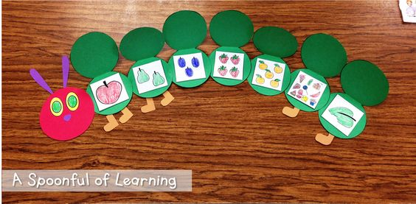
Science: Go on a mini beast hunt in the garden/local park. Draw your child attention to the bugs. If you have magnifying glass you can take it with you and observe insects closely. Can you find caterpillar, butterfly, ladybug, ants?
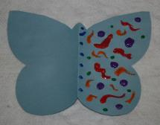
Art: Folding paper butterfly picture- cut out a shape of a butterfly from the paper. Fold it in half and encourage your child to design it. Fold the unpainted side over the painted one and press together to create perfectly symmetrical butterfly.
P.E.:
- Practice marching while listening to the song: The Ants Go Marching` https://www.youtube.com/watch?v=Pjw2A3QU8Qg
- Listen to the song `Creepy Crawly Calypso` song : https://www.youtube.com/watch?v=kKClvjPCgUI and complete the actions theat the minibeasts from the song do e.g. pretend to play the drum like a spider, play accordion like a butterfly etc.

Weekly recipe:
Make a fruit salad/fruit smoothie using the fruit from the story (apples, pears, strawberries, oranges, watermelon). Children to cut, taste the fruit and indicate if they like it or not. Alternatively blend fruit to make a delicious summer smoothie.

https://livingwellmom.com/rainbow-fruit-salad-recipe-perfect-for-kids/

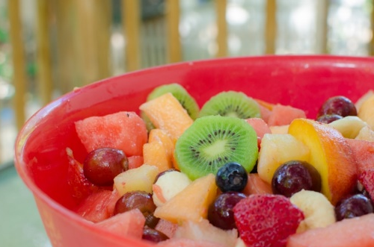
https://www.bbcgoodfood.com/recipes/collection/kids-smoothie

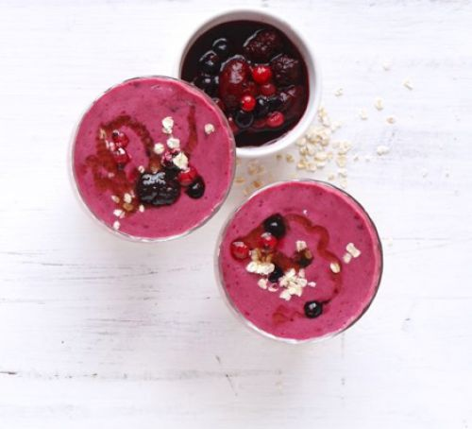
Week Five:
Theme: Walking Through the Jungle
Reading:
Walking through the jungle – Barefoot Books - https://www.youtube.com/watch?v=plvY0quSyJg
- This is a great call and response story - why don’t you try to repeat the line after you’ve heard it the first time.
- Prompt your child to clap or move along to the rhythm
- You could also add some cuddly toy animals or sensory props to feel and explore. In the story there is a different animal in each place: jungle – lion, ocean – whale, mountains – wolf, river – crocodile, desert – snake and icebergs – polar bear.
Maths:
Number rhymes:
- Five Little Monkeys Swinging in a Tree: https://www.youtube.com/watch?v=t2jnqUyxck0
- One Elephant Went Out to Play - https://www.youtube.com/watch?v=wQf6yWEScB8
- Alice the Camel - https://www.youtube.com/watch?v=9sN_RqxXGMw
- Playdough – add teeth to your crocodile (playdough mat attached) using playdough. Can you count how many?
- Exploring numbers & counting – can you draw numbers in the mud outside using sticks? Can you count how many trees you can see on your walk?
Science:
- Explore different habitats from the story using sensory props. Use a tray or bowl (whatever you have) to create two different habits and look at the differences between them. There are lots of different things to choose from:
- Jungle – leaves, sticks, green shredded paper
- Ocean/ river – water, blue jelly, custard & blue food colouring, blue glitter
- Desert – sand (you could also make your own edible sand by crushing up food items such as cereal), add gherkins for cactuses
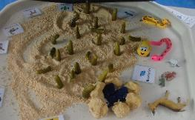
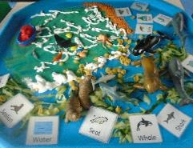
- Icebergs – ice, crazy foam spray, fake snow (3 cups of flour, 3 cups of cornflour & oil mixed together)
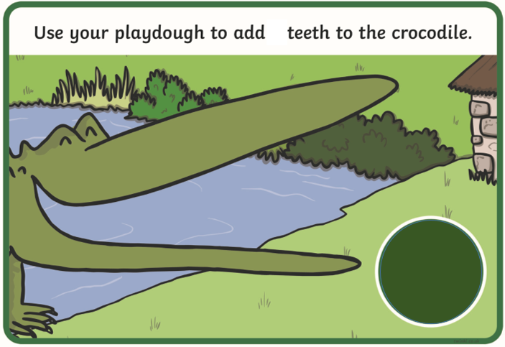
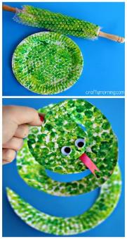
Art:
- Paper plate animals:
- Lion - stick orange, yellow and brown strips of paper around the edges of a paper plate and draw a face on
- Wolf – paint/ colour/ collage a plate grey and add some eyes and a nose
- Snake - wrap bubble wrap around a rolling pin, roll it in green paint and roll it onto your plate then cut a spiral out to create your snake!
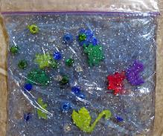
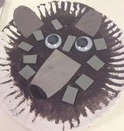
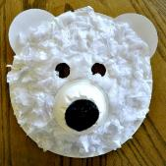
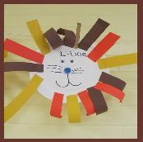
- Polar bear – use tissue or cotton wool and stick it onto your plate, add a black circle nose and eyes. You can use a paper cup to create a 3D nose
- Sensory bags – create a river with a crocodile or ocean with a whale like we see in the story! You will need a zip lock bag, hair gel and sequins/ glitter/ plastic animals. See this video for how to make one: https://www.youtube.com/watch?v=Xp7GMDrFCqc
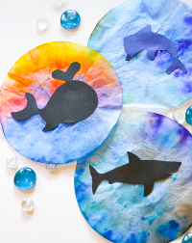
- Water spray pictures – you need piece of kitchen towel or a coffee filter, felt pens and a water spray. Use the pens to draw onto your kitchen roll/ coffee filter however you like. When you have finished, spray your drawing with the water spray and watch the colours run and merge together. You could add a cut out of an animal too.
P.E.:
- Go on a walk to the woods – How many natural items such as sticks and leaves you can find? Can you find any mountains (hills) to climb like in the story? Can you find any rivers to look at? What things can you see and hear?
- Moving like animals – can you explore moving your body in different ways like different animals? Can you slide along the floor like a snake? Can you stomp like an elephant? Can you run like a cheetah?
- ‘Walking Through the Jungle’ action song- https://www.youtube.com/watch?v=GoSq-yZcJ-4
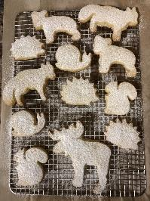
Weekly recipe:
Animal shortbread biscuits:
- 1 cup of butter
- ½ cup icing sugar
- 2 cups of plain flour
- Mix all the ingredients together in a bowl until a dough is formed
- Sprinkle some flour onto the table and roll the dough out so it is an even thickness
- Use animal cutters if you have them to cut the dough. If you don’t have any cut some squares or circles instead (you can still make animals by decorating your biscuits when they are cooked)
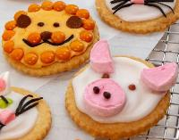
- Place the cutouts onto a baking tray covered with baking paper or greased with butter. This is so your biscuits do not get stuck!
- Put in the oven on 180 for 10mins and then check and see if they have browned. If not put back in the oven and keep checking until they have.
- Take them out and leave them to cool down. When they are cool, you can use icing to decorate them, or eat them plain

- Jungle fruit snacks – Can you make a jungle picture or jungle animal using fruit?
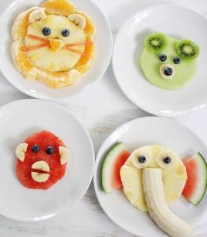
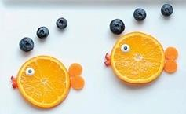
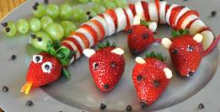
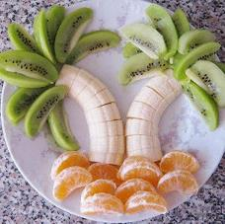

Week Six:
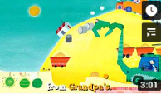
Theme: My Family
Reading: Stories on YouTube
https://www.youtube.com/watch?v=wKcrsv_t8Ko
https://www.youtube.com/watch?v=MIm_H01Z6Ss
Vocab: my family words and phrases
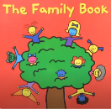
https://www.youtube.com/watch?v=O5oeOrfvlkY
Maths:
Some action songs to enjoy together:

‘The Family’ song
https://www.youtube.com/watch?v=ii_LtHrEiao

‘I Love You, One Big Family’ song
https://www.youtube.com/watch?v=BcA6muHkGXc

‘Family Finger’ song
https://www.youtube.com/watch?v=G6k7dChBaJ8

Counting together, how many are in my family? How many are boys? How many are girls? How many fingers, toes, eyes do I have?
Science:
- A child friendly web site with steps to follow in a range of easy science experiments you can do at home using things found around the house. https://www.sciencefun.org/kidszone/experiments/

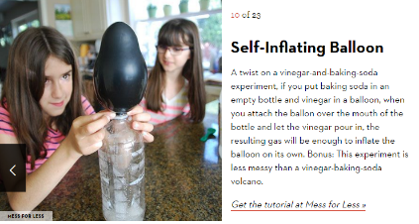
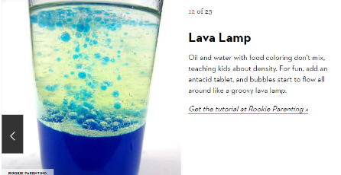
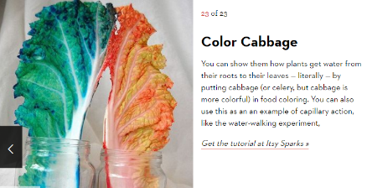
- You can even try this with flowers picked from the garden

Art:
- Hand print family tree art
- Make a family book using photos
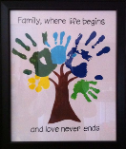
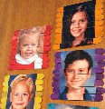
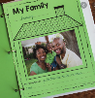
- Use some photos and cut them in half and play a matching game or cut them into strips and put them back together
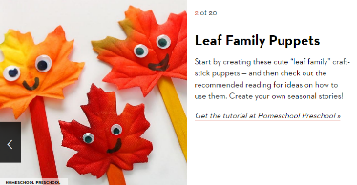
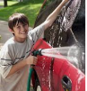
P.E.:
- Can always be fun helping around the house
- Some action and movement songs to enjoy together
‘I’m So Happy’ action song
https://www.youtube.com/watch?v=G_0iMjRHUEg
‘We are Family’ action song
https://www.youtube.com/watch?v=foptl0BeXnY
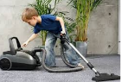
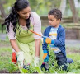
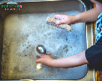

Weekly recipe:
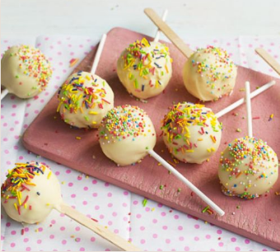
- Cake pops- Be creative and make family pops. Decorate with faces and add sweets to make hair!
https://www.bbcgoodfood.com/recipes/cake-pops

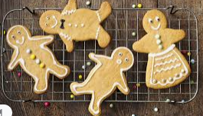

- Here is and easy gingerbread man recipe you can make and create a family portrait out of cookies! https://www.cookingwithmykids.co.uk/gingerbread-men/

