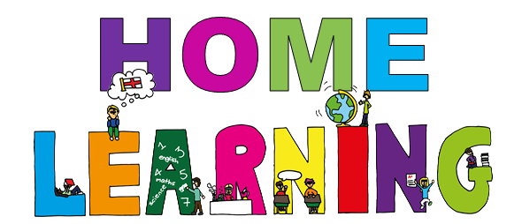

LISS Pathway Home Learning Pack
Theme: The Seaside
Reading: ‘The Lighthouse Keepers Lunch’
Share the story using the links:
- https://www.youtube.com/watch?v=oBmVO-MlVrk or
- https://slideplayer.com/slide/12126148/

Activity Ideas:
English
- Try making a writing sand tray and making marks, letters in the sand using a finger.
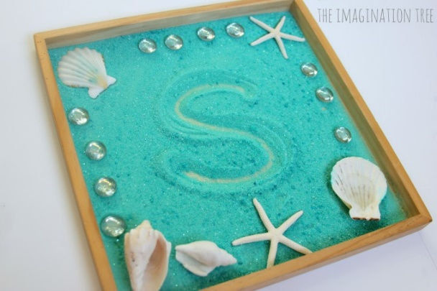
- Plan a picnic. Think about your favourite foods. What do you need to take with you?
- Make a shopping list and go shopping for items and ingredients to make a picnic
- Draw a picture of your favourite lunch

Maths:
- Play with sand or water in a sand or water tray. Use different containers to full and empty the sand and water. Reinforce vocabulary of full/empty/we/dry.
- Build sandcastles in different shapes.
- You could try measuring objects using non-standard forms of measuring e.g. draw around you hand a lot of times and cut out. Use the handprints to measure different things.
- Treasure Hunt Sensory Tray- Create a simple treasure hunt activity with household items and shiny items that you can hide and find. Count the number of similar objects found,
- Make your own fishing game. Cut out shapes of fish, decorate, put a paperclip on the nose. Using a stick put a small magnet on the end. Go fishing.

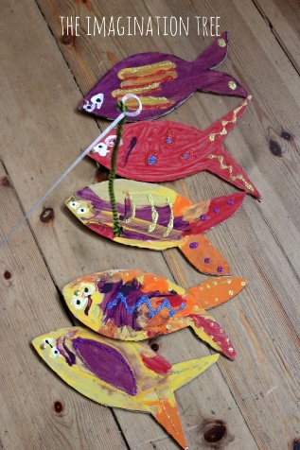
- Patterns – draw lighthouse and use different colours to create a the stripes. Can you make a repeating pattern.

Science:
- Pack a bag for your picnic to match the weather
- Talk about different clothing for wet and dry weather.
- Make a seaside bottle from junk
Using a plastic bottle, fill it with water, add some food colouring, find some things to put in your bottle, glitter, sequins, fish, tape the lid shut.
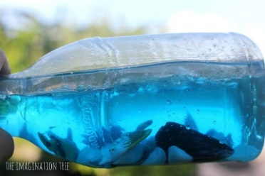

- When on your picnic look and listen. What things can you see/hear?
- Collect natural materials from your picnic to make into a picture e.g. grass, twigs, leaves etc.

Cooking
- Make a sandwich to take on a picnic,
- Make cupcakes –

Recipe
- 110g softened butter
110g golden caster sugar
- 2 large eggs
½ tsp vanilla extract
- 110g self-raising flour

For the buttercream
- 150g softened butter
300g icing sugar
- 1 tsp vanilla extract
- 3 tbsp milk
Food colouring of your choice
- Heat oven to 180C/160C fan/gas 4 and fill a 12 cupcake tray with cases.
- Using an electric whisk beat 110g softened butter and 110g golden caster sugar together until pale and fluffy then whisk in 2 large eggs, one at a time, scraping down the sides of the bowl after each addition.
- Add ½ tsp vanilla extract, 110g self-raising flour and a pinch of salt, whisk until just combined then spoon the mixture into the cupcake cases.
- Bake for 15 mins until golden brown and a skewer inserted into the middle of each cake comes out clean. Leave to cool completely on a wire rack.
- To make the buttercream, whisk 150g softened butter until super soft then add 300g icing sugar, 1 tsp vanilla extract and a pinch of salt.
- Whisk together until smooth (start off slowly to avoid an icing sugar cloud) then beat in 3 tbsp milk.
- If wanting to colour, stir in the food colouring now. Spoon or pipe onto the cooled cupcakes.
- When cooking talk about safety in the kitchen

Art:
- Create sand paintings – put glue onto paper, sprinkle sand over the glue.
- Paint pebbles collected
- Use collage materials to create seaside pictures
- If you have some bubble wrap use it to paint with. Paint the bubble wrap and use it to print onto different shapes.

- Use a cardboard egg box, paint it blue and make a sea scene using shells, pebbles and cut out fish and seaweed.

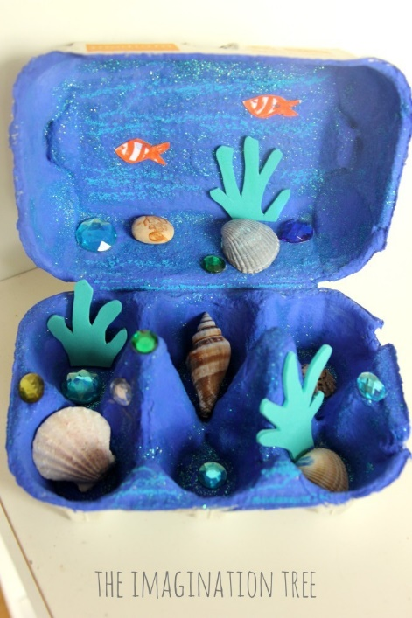

- You could use the bubble wrap as a background and paint it blue with green seaweed. Draw and cut around your hands to make fish. What else can you make?
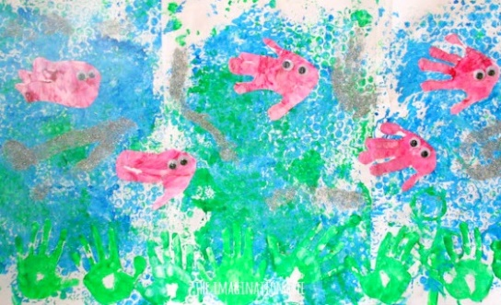
P.E.:
Suggested ideas for physical activities from You tube:
- Just dance – get active to pop music
- Brain Breaks for Children – active songs

Theme: The Gingerbread Man
Reading: ‘The Gingerbread Man’
Share the story using the links:
- https://www.youtube.com/watch?v=hsEorBffl3o
Activity Ideas:
English
- Try making a writing tray and making marks, letters in the sand using a finger.
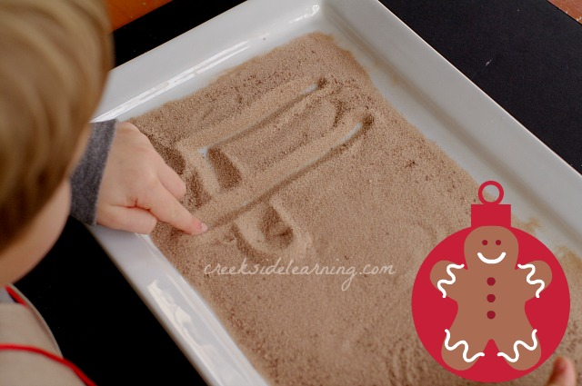
- Or instead of sand, could you use? Salt, Ginger, Cinnamon, Nutmeg?

- Create a picture of the gingerbread man
- Can we think of some different CVC words to place on the ginger bread man?
- ( R ) AN ( M ) AN ( C ) AN or maybe some different describing word?
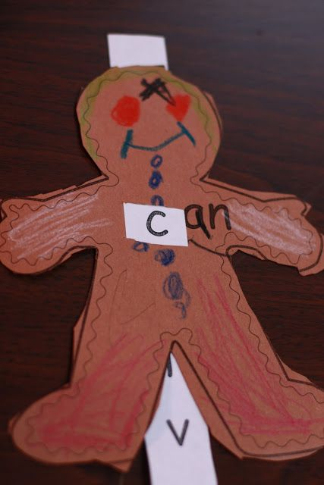
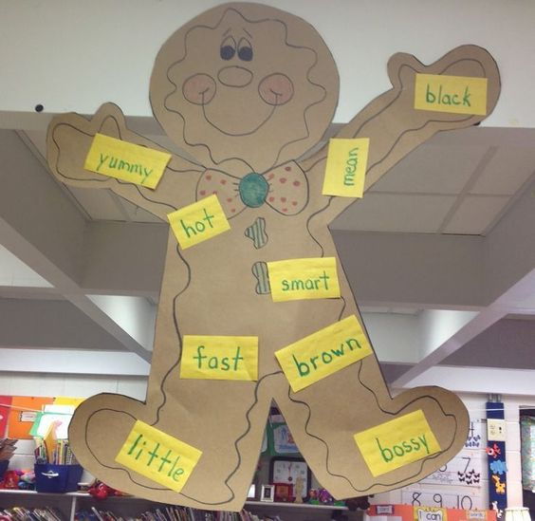

Maths:
- Making playdough together using this recipe:

- 1 Cup of Flour
- ½ Cup of Salt
- ½ Table Spoon of Ground Ginger
- ½ Table Spoon of Ground Cinnamon
- 1 Table Spoon of Vegetable Oil
- ½ Cup of Water

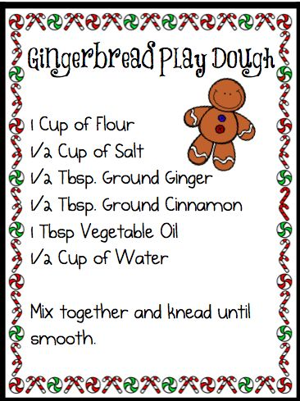

- Encourage the children to count the ingredients into the bowl
- Once made, try rolling the dough into little balls to use as the gingerbread man’s buttons
- Count together how many buttons he has?
- Use playdough mat below

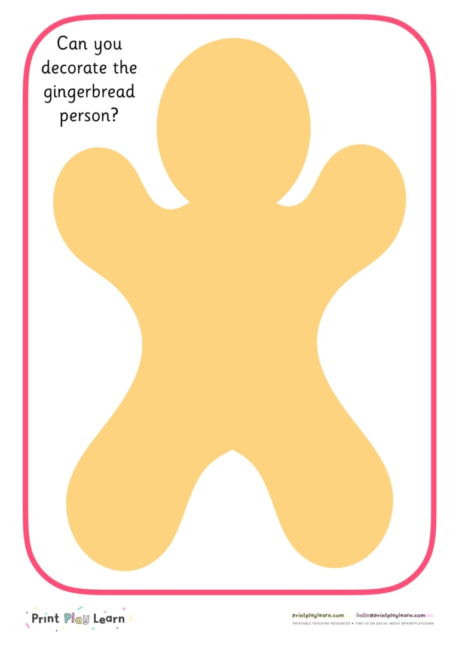

Science:
- Make a gingerbread man picture using Puffy Paint!
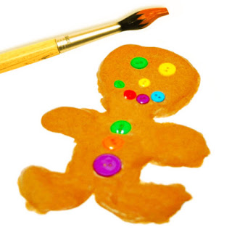

Microwave Puffy Paint Recipe

- 1 cup self-raising flour
- 1 teaspoon salt
- 1 cup water
- Food colouring or Ginger

- 1. Squeeze the puffy paint onto your paper/cardboard to create designs, images, or patterns as desired.
- 2. Place puffy paint art in microwave and microwave on high for about 30 seconds. A bit more for artworks that have a generous amount of paint and a bit less for artworks that use less.
- 3. Remove, let cool, then touch and admire how the paint puffed up and cooked solid.

Cooking
- Make a real gingerbread man that you can eat!
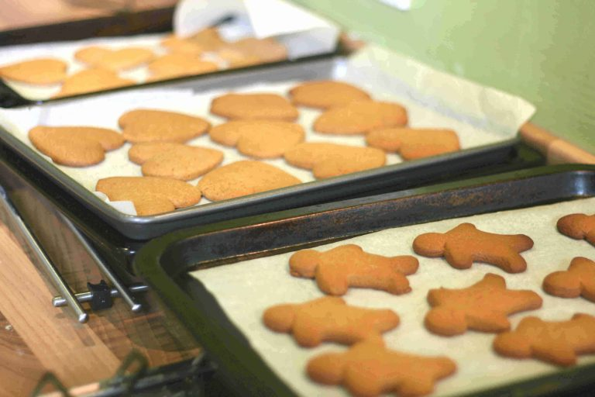
Recipe
Time: 30 minutes + 10 minutes baking
Serves: approx 30 men
INGREDIENTS
350g (3 cups) plain flour
1 tsp bicarbonate of soda
2 tsp ground ginger
100g (1/2 cup) butter
175g (1 cup) light muscovado sugar
4 tbsp golden syrup
1 large egg
Find the recipe at: https://www.cookingwithmykids.co.uk/gingerbread-men/

- When cooking talk about safety in the kitchen

Art:
- Create your own gingerbread man out of Toilet Roll, and Card..
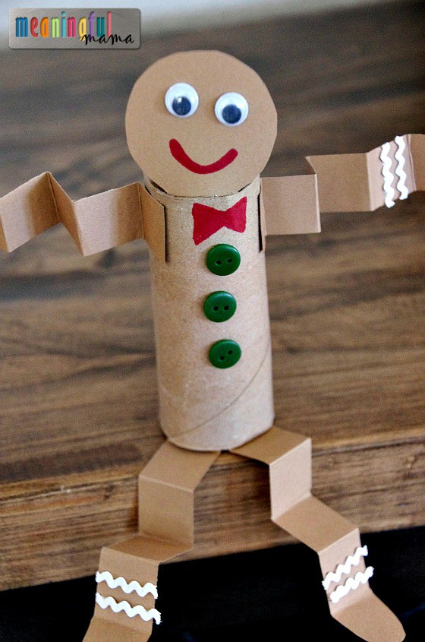

- Or instead… you could use the finished toilet rolls to do some printing with..

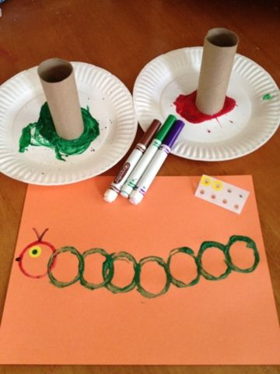

P.E.:
Suggested ideas for physical activities:
- Gingerbread assault course (start in the kitchen, then through the door (hoop) over the gate (skipping rope) away from the animals (under a blanket) and across the stream (balancing on a straight line).

- Or…

- Even pretend you are the gingerbread man, and you need to..

- ‘Run, Run as fast as you Can!’

Theme: Science
Day one – Space
Reading: Space song Rocket Ride
- https://www.youtube.com/watch?v=SAHy_2IFFGA
- Listen through the story talk about space, rockets and planets!
- Pause the story and see if your child can say the missing words
Maths:
- Sing ‘5 little men in a flying saucer” counting down from 5 and joining in with the “whoosh” actions
- Make a picture of a rocket by cutting up paper into squares, circles and triangles.
- Decorate different sized and shaped boxes with paint and collage material to make your own 3D rockets, order from little up to big. Count down from 10 and blast off! Make a mobile with them by hanging them on a coat hanger with different lengths of string/wool.
Day two – Float & sink
Reading: Port side Pirates
- https://www.youtube.com/watch?v=_qAngsMJD3I
- Listen together talk about floating and sinking! Pause, can they show you different directi ons. Left, right, forward, backwards?

Maths:
- Experimenting with heavy and light! Find objects around the home, comparing weights, is it heavy or light?
- Predict if it will float or sink
- Now test it….Get a bowl of water, or some water in the bath, now watch, does it float or sink? Did you predict correctly? Record your findings by grouping those that sunk and those that floated. Or record on a piece of paper.
Day three – Sound
Reading: A book at home of your choice
- Read the book together, experimenting with sound!
- Can you change your voice to make it loud or quiet, can you do silly voices, high and low pitches? Encourage your child to retell the story imitating your sounds and tones.
- Can you make an echo with your voice? How can you make an echo?
- Let’s get moving: Turn on your favourite record and dance!
- Now how about musical statues or musical chairs!
- How does sound travel – phone Grandma or auntie/uncle or a friend. Tell them you are experimenting with sound! Now can they change their voice? Did it make you laugh?

Day four – Mini-Beasts
Reading: Over on the Meadow
- https://www.youtube.com/watch?v=C6ljGXMMB-g
- Listen to the story together talk about animals and mini-beasts
- Where do different creatures live, in trees, underground, in the jungle on a farm?
- Go out-side or look out of the window, what can you see? Can you take a photo of the creatures living near you?
Maths:
- Make playdough (1 cup of flour, ½ cup or salt, 1 dessert spoon of oil, mix with water until the desired consistency. Add food colouring to the water. Or bake and then paint)
- Use the playdough to make a mini-beast garden. Put your Mini-beasts in a small box (shoe box, or cut up cereal box) Collect leaves to make it look real.
- Ladybirds, don’t forget his spots! How many spots?
- Big and little spiders, with 8 Legs!

Day 5 – Light and reflections
Reading: A book of your choice from home – Make a dark area to read together, draw the curtains! Can you see it clearly? How can you see the words and pictures better?
- Find a mirror. Can you see your reflection?
- Can you name all the features on your face?
- Where else can you see your reflection?
Maths:
- Count how many objects in your home that make light. Don’t forget to look in the fridge! Look out-side, where can you see light?
- How do they work? Battery, electricity
- Draw a self-portrait, or a portrait of your mum, dad, sister. How many eyes? Choose the right colour, is their hair short or long?
- Can you stop light with your body or hand, look at shadows can you draw around a shadow?
- Can you make a light catcher/reflector? Hang old CD’s or shiny objects and materials in the garden, or near a window. Watch them move in the breeze and catch the sun light.

Theme: Learning at home
In the kitchen
Reading:
- Matching words or symbols to objects. Use post-it notes or paper. Draw a simple picture or write the word. Can your child label the correct object?
- Read/recognise packaging labels?
- Help write a shopping list?
Maths:
- Help sort the cutlery tray, matching the same objects.
- Where does it belong? Tins in the cupboard, cheese in the fridge etc.
Science:
- Cook simple shortbread together
- https://www.bbc.co.uk/food/recipes/shortbread_1290
Independence:
- Help wash up?
- Help set the table for dinner?
In the Bathroom
Reading:
- Label objects in the bathroom (as above)
Maths:
- Count to 20 when you wash your hands
- Time 2mins when you brush your teeth
- Follow the brush your teeth sequence
Science:
- Have fun getting wet in the bath.
- Explore the bubbles, make more bubbles by blowing through a straw
- Make snake bubbles – Cut a plastic bottle in half, cover the cut end with a flannel or dish cloth, secure with an elastic band. Dip the cloth into the bubbly bath water and blow through the other end, watch the snake of bubbles get longer and longer!
- Now you are wet, how to you dry yourself?
Independence:
- Can you wash and dry yourself?
- Can you put you dirty clothes in the laundry basket?
- Can you use the toilet yourself?
In the Bedroom
Reading:
- Tidy up your toys, can you put all thing away that start with “m” or “b” etc.
- Find your favourite book to read at bedtime.
Maths:
- Sort your clothes, match colours or pair of socks
- Where do your toys go? Where do your clothes go, sort clean and dirty.
Science:
- What time is it? Night time, day time?
- Is it dark or light?
Independence:
- Can you get dressed/undressed on your own?
- Can you help make your bed?
Outside
Reading:
- Check your shopping list.
- Do you recognise the name of the shop?
- Can you find the shopping you need?
Maths:
- What shop do you need to go to?
- In store is the shopping you need on a shelf or in the fridge?
- Can you help pay for the shopping?
- How will you get there, should you go left, right or straight on?
- Do you have enough shopping bags?
- Is the shopping heavy or light?
Science:
- What’s the weather like, what clothes/shoes do you need?

Independence:
- Can you ask for help in the shop?
- Can you push the green button and wait to cross the road?
- Did you wash your hands when you got home?

