Six-Week Learning Pack
Summer Holidays
EYFS Pathway

Week One:
Theme: Under the Sea
Reading: ‘A Whole in the Bottom of the Sea’
- https://www.youtube.com/watch?v=R1Qn2bcZRTo
- Listen through the story with your child- do not hesitate to sing along!
- Prompt your child to clap or move along to the rhythm as they listen
Maths:
- Sing ‘1, 2, 3, 4, 5 Once I Caught a Fish Alive’ with your child. Focus on engaging with them in a way that they prefer and sing along together
- Treasure Hunt Sensory Tray- Create a simple treasure hunt activity with household items and shiny items that you can hide for your child to find
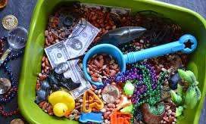
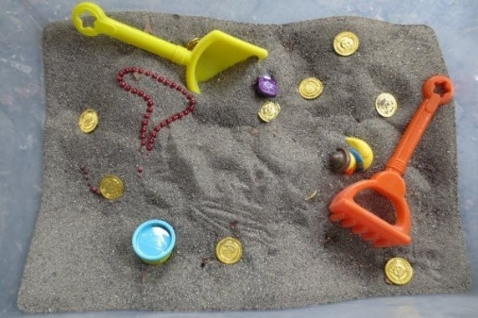

- Count the objects with your child as they find them
- Sort objects by colour, shape or category as they are found
- Prompt your child to say colours or shapes
Science: Seaside Sensory Bottles
- Collect some empty plastic bottles of different sizes along with some tiny items that will fit inside e.g. glitter, sand, small shells or stones, tiny plastic fish etc.
- Prompt your child to choose what they would like to put inside, help them to post the items in
- Assist your child in filling the bottle about half-way full with water and adding in a few drops of blue food colouring
- Seal the bottle well with a thick tape
- Allow your child to explore their bottle!

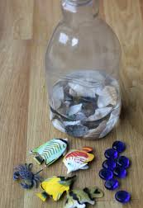
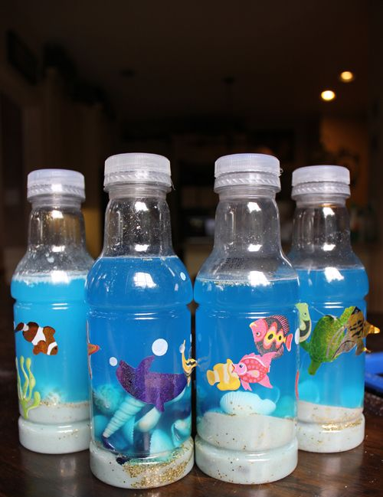

Art: Seaside Bubble Paintings
- Prompt your child to choose their paint colour and help you to mix the paint in a plastic cup with a little bit of water and a squirt of washing up liquid
- Provide your child with a straw that has a hole cut in it so that they cannot suck up the paint mixture
- Model blowing through to create bubbles, prompt your child to do the same until the bubbles overflow onto a piece of paper
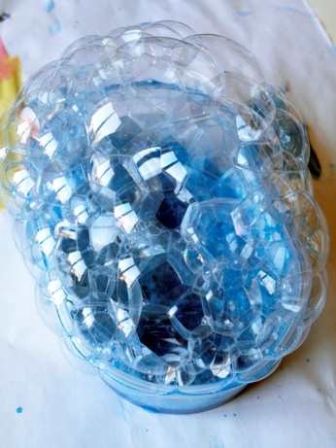
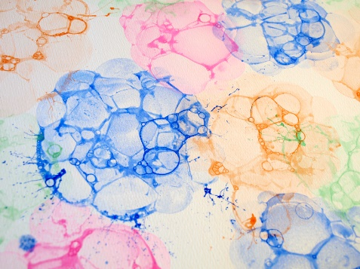

P.E.:
- ‘Popcorn the Dolphin’- A Cosmic Kids Yoga Adventure
- https://www.youtube.com/watch?v=YR1OxBk8BF4

Weekly recipe: Seaside Cupcakes
- https://theimaginationtree.com/beach-cupcake-recipe/
- Lead your child in making the cupcakes together, encouraging them to help mix, pour and spread the icing on afterwards!

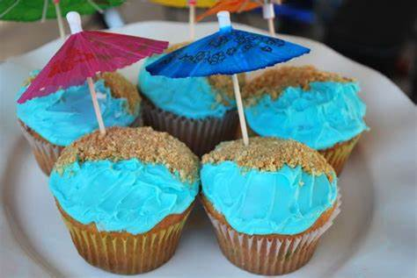

Week Two:
Theme: Things that Move!

Reading: Cars/ Left and Right
COOL CARS (Amazing Machines) by Tony Mitton and Ant Parker https://www.youtube.com/watch?v=4VZLVcYsaQk
Book 20. Pete the cat Go, Pete, Go https://www.youtube.com/watch?v=UU-86Ibb5G

Make and outline of Left and Right hand – Colour or mark-make over it. Cut out the hands and mark LEFT and RIGHT. Match a pair of gloves to the LEFT and RIGHT. When out walking or in the car, use the vocabulary LEFT and RIGHT as you travel.

Maths: Directions - Forward and Backward
https://www.youtube.com/watch?v=4LfN12phMW4 Song for counting forward and backward 0-10
(To repeat and learn “as a song” – counting by rote.
https://www.youtube.com/watch?v=uY421EKYMjQ Join in a copy the movement and use the directional language
Step in coloured water or paint and make footsteps on concrete path or A4 paper joined together. (6-10 steps.) March and say “Left Right Left Right” as you make the footprints. Now count the steps and write the numbers next to each step. March over the steps and count or say “Left Right” whilst stepping.

Science: Push and Pull
https://www.youtube.com/watch?v=E-SnC_WKsC g Song about forces
https://www.youtube.com/watch?v=5t1frJFPSBg ….some ideas for talking about forces at home.
Activity: You need, a ball, toy car, an apple and banana (or something that will roll and not).
- Push a ball with your hands and feet. (Use Science language of push.) ie roll and kick movements
- Push a ball to the ground and push it up. (Use Science language push up, push down) ie bounce and throw movements.
- Push various objects that roll and not, for example a car, ball, block, banana, apple. Explore those that roll and those that don’t.
- . (
Suggestions
Let your child help vacuum – Use the language push and pull…AND MAYBE STOP!

Art: Paint with toy cars
https://www.youtube.com/watch?v=PG1Hxqap9Cw

P.E.: Walk to a nearby park and kick a ball and have a run! If no nearby park – Take a brisk walk around a few blocks on the pavement. If stuck inside – learn to do star jumps and count as you jump and if too hard, march on the spot!
OR/ Try this Boogie.
CBeebies: Boogie Beebies – Dig it. https://www.youtube.com/watch?v=Mw0C0ybhqTo

Weekly recipe:
Now, I’m not going to lie, it does take a bit of effort to make these. They turned out really well, but you have to give yourself a day to let them set, and then at least 45 minutes to push them all out of the straws. So it’s definitely not a last minute thing.

Jelly Worms: How to make a Bowl Worms
These Jelly worms are amazing. They have some wiggly movement – so you can have a “Fun With Food” session once set and then eat them! Use some cocoa powder or oats for soil.

Ingredients
- 1package Orange and Green Jelly
- 1 pack unflavoured Gelatin
- Boiling Water (Follow instructions on packages of Jelly/Geletin
- Flexible Straws
- 1/4C Whipping Cream
- 1Wide Mouth container (for the straws)

Instructions
- In a large measuring cup, combine the Jelly and the unflavoured gelatin.
- Add the boiling water (less 1/4C) and stir until the gelatin is completely dissolved.
- Chill in the fridge for 20 minutes or until lukewarm.
- Stretch each of the straws open to extend the flexible parts and then put the straws into the jar with the flexible side closer to the bottom.
- Pour the whipping cream into the Jelly mixture and stir.
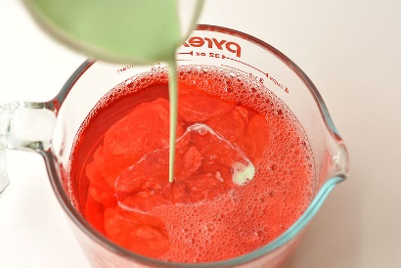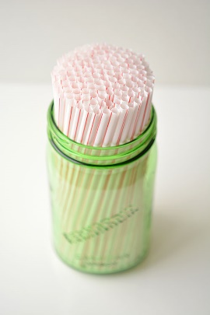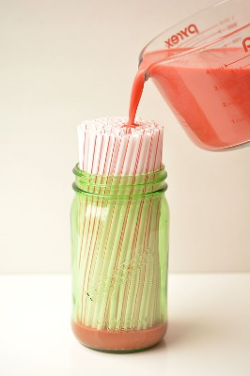
- Pour the mixture through the top of the straws until it fills the container. The straws will self level so don't worry about filling each individual straw.
- Chill for at least 8 hours.
- Run each straw under hot water for a few seconds.
- Pinch the straw from the top down to squeeze out each worm.
- If you are making these in advance, squeeze the worms onto a waxed paper lined baking sheet and store, covered, in the fridge until you are ready to serve them.

Notes: The whipping cream separates from the Jelly as it sets, so the bottom part of each worm will have a small portion of clear Jelly and the top will be opaque.
Don’t pour too fast though, or this will happen. 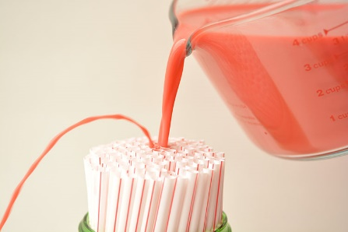
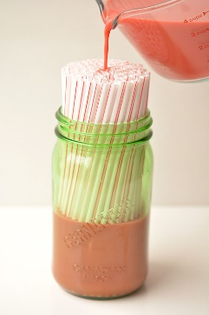 It will self level through all of the straws so you don’t need to worry about filling each individual straw.- just pour it into the middle of the jar and it will even itself out.
It was a bit of a challenge getting the first straw out of the jar, but I managed to wiggle it out without too much damage. The ones after the first straw were much easier to remove.

Art: Left and Right/ Push and Pull/ Forward and Backwards Left and Right
https://www.youtube.com/watch?v=4VZLVcYsaQk Song

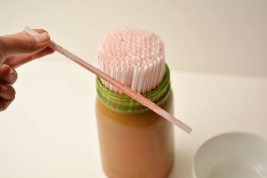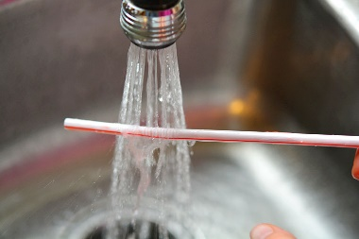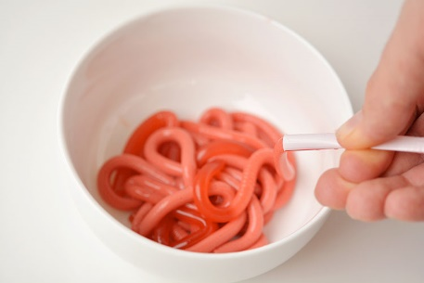
Run the straw under hot water for a few seconds. I ran them under hot water until the leftover Jelly gunk on the outside of the straws washed off. If you don’t do this part, you won’t be able to get them out of the straw. Starting at the top of the straw where it’s empty, pinch with your fingers to squeeze the straw closed, and then slide your fingers down the straw to squeeze out the worm. You have to squeeze out Every. Single. Worm.
Alternative recipe @ https://www.delish.com/cooking/recipe-ideas/recipes/a55257/jelly-worms-recipe/

Week Three:
Theme: Wet and Dry
Reading:
https://www.youtube.com/watch?v=MV8snbVhXKU The Rain Came Down

Maths: 1-1 correspondence
Hide objects, for example Lego, pegs, teaspoons… in the MOON SAND you made in the ART section. (Or use coloured water).
Use the cut out hand from last week’s sessions, or make another, and use that and your own hands to indicate a number.
Find me …. Pegs in the sand/ water. Match each object to a finger. Use the language “same”. If your child is ready to count, guide them to touch one object at a time and count with them, emphasising the last number.
You can also use dots on card. Instead of saying find “3”, show the card with 3 dots and say: “Find me this many”.
This is pre-counting to make sure your child is counting one object at a time.
Song to count fingers (And it’s OK to count fingers)
https://www.youtube.com/watch?v=q6ARHeFZJ8U

Science: https://www.youtube.com/watch?v=xNw1SSz18Gg .
Art:
https://www.youtube.com/watch?v=ZQB8vPkYdYo Make MOON SAND with FLOUR and BABY OIL.
Use moulds or use free hand to make different shape.s

P.E.:
Get changed into swim wear or shorts… Run under the hose outside.
Fill water balloons and throw to a target.
Try to visit a swimming pool at a leisure centre.

Weekly recipe:
Squeeze orange juice: If you don’t have a juicer – then cut oranges in half and squeeze with your hands. Try a lemon or lime – and experience “sour”.
Make ice lollies with diluted cordial or plain water.
Freeze a plastic container of water to make a larger chunk of ice – Play with it in a container outside or on a pathway and watch it melt.

Week Four:
Theme: Mini-beasts
Reading: the very hungry caterpillar
- https://www.youtube.com/watch?v=75NQK-Sm1YY
- Listen to the story with your child
Name and sign the different items of food throughout the story

Maths:
- Sing- the ants go marching one by one- march around the house/garden together following the leader.
- Make a chart of different mini-beasts with pictures, go to local park- see what mini beast you can find. Mark on chart and count them as you go
- Sorting- mini beasts with legs/spots/wings etc.
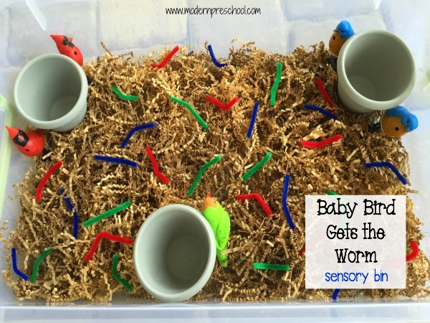

- baby bird gets the worm sensory bin- cut up pipe cleaners and hide amongst shredded paper/wool/sand/dry mud. Get children to pick up the ‘worms’ using pegs to develop fine motor skills and put into cups (nests) for the birds. Sort into colours/ count the worms at the end.

Science:
wiggly worm sensory play- mix cornflour, coco-powder and water together with your child to make clean mud. Throw in some rocks/stones and spaghetti for the worms- explore!
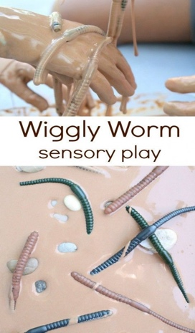

Art:
- Rock bugs- gather some rocks and stones, prompt your child to choose the colour they would like to paint with
- Allow children to paint the stones and gather and crafty materials to add effect such as pipe cleaners, bubble wrap and googly eyes.
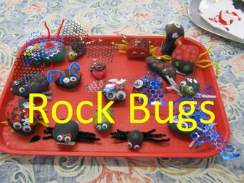

- Spaghetti painting- wrap a handful of dried spaghetti in string, cook just hand of the spaghetti until it becomes soft.
- Give the spaghetti paintbrush to your child with some paint and paper and let them explore!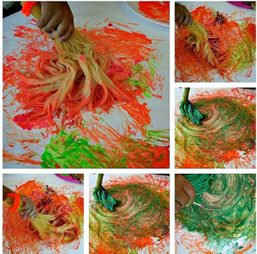

P.E.:
- dance to flight of the bumble bee music
https://www.youtube.com/watch?v=X14kC-sEH0I
- move like a minibeast-use props to support minibeast movement e.g. scarves for butterflies/hoops as waterlilies for frog
- over and under instruction games-moving like a worm/caterpillar

Weekly recipe:
- ladybird strawberries:
- melt some milk chocolate squares in the microwave or on the hob
- once melted, dip the top of the strawberries in the chocolate and leave to dry.
- Transfer the remaining chocolate to a sealable plastic bag. Cut off 1 corner. Pipe dots on each strawberry. Set aside to set.
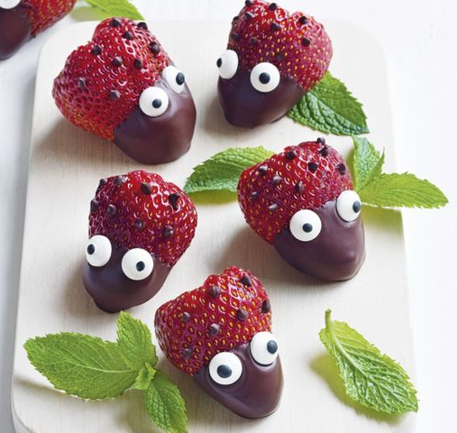

Week Five:
Theme: Walking through the Jungle
Reading: The animal Boogie
https://www.youtube.com/watch?v=25_u1GzruQM

- Watch the book with your child. Dance along to the song and show your child the actions.
- Look at other books/ pictures of animal, point to the animals and name them for your child.

Maths: Find toy animals for your child to play with.
- Line the animals up and count them
- Choose different size animals and use the language of size – e.g. big elephant/ small cat/ long snake
- Find different containers that you can put the animals into. How many animals can fit in each container? Use the language ‘count’, ‘how many’, ‘too big’, ‘too small’ etc.
Science: Exploring different materials
- Find different media that you can make the toy animals/ or your child walk through. You could use cereal, dry rice, flour, scrunched up paper etc. Use words to describe the feeling/ sound – soft flour, crunchy cereal etc.
- Freeze things into ice cubes, like small toys/ flowers/ plastic letters etc. Let your child explore the ice and try to find out how to get the ‘treasure’ out. What happens to the ice when you hold it?
Art: Print making
- Use paint to dip the toy animal’s feet in and make footsteps across the paper (use your child’s feet if you’re brave enough!)
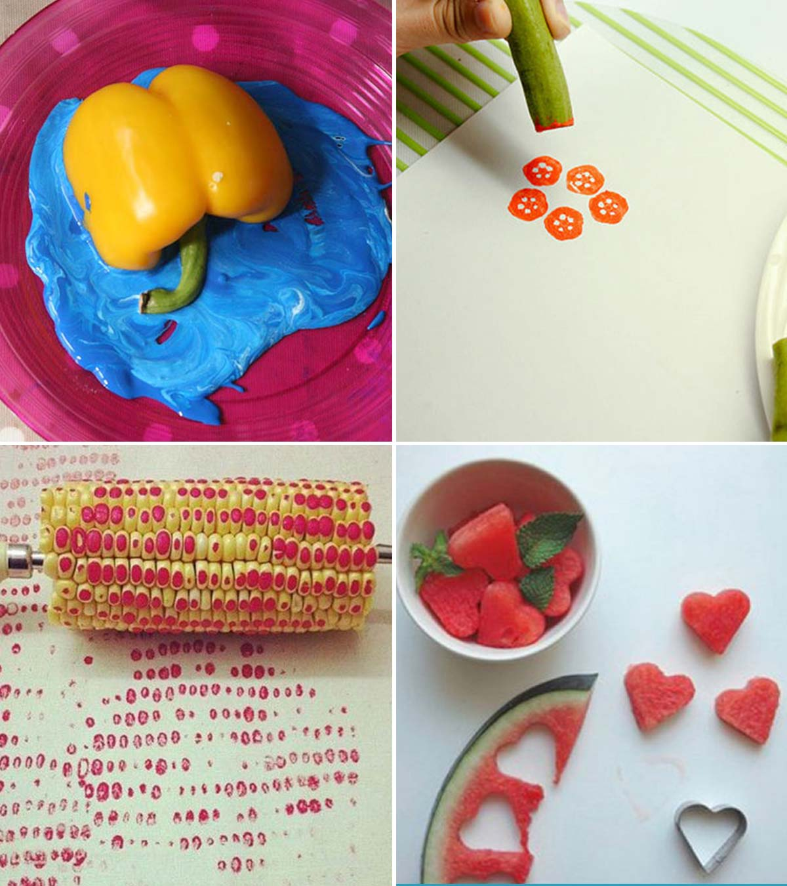
- Let your child stand in water and look at the wet footprints outside
- Use fruit and vegetables to make prints
P.E.:
- Watch our story and see if your child can move like the animals.
- Explore moving at different levels – can you move on your tummy like a snake? Can you walk on your tip toes like a tall giraffe?
- Try ‘cosmic kids yoga – jungle safari https://www.youtube.com/watch?v=C4CaR0syf1g
There is also ‘Walking through the jungle’
Weekly recipe: Fun with food
Cut bread/ pastry into shapes and make an elephant head – encourage communication by offering your child different things for the eyes – raisins/ cut up cucumber/smarties/ bits of grapes/ chocolate buttons etc

Week Six:
Theme: My Family
Reading: Full, full, full of love

https://www.youtube.com/watch?v=3DLMsKM1akI 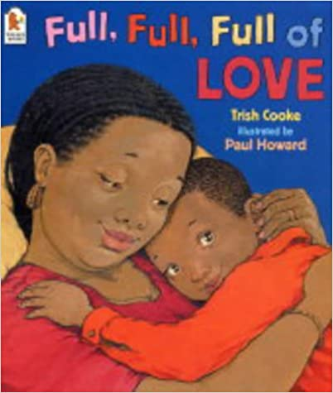
- Watch the video with your child
- Look at photos of your family and talk about the family members

Maths:
- Ask your child to lie down and measure them with a piece of string, keep the string somewhere safe with your child’s name and age on it along with the date. Take it out again at the same time next year and see how much they have grown.
- Draw around your child’s foot, then draw around your foot. Talk about whose foot is bigger, whose is smaller. Find things around the house that are the same size as their foot.
- Use paper plates and coloured paper to make a shape pizza. Cut out different shapes and stick them to the plate, talk about the different shapes and colours

Science: Big bubbles!
https://www.youtube.com/watch?v=eulGicgavBM
- There is a recipe in the video, but an alternative recipe is:
  - 1 cup or corn flour, 1 cup of Fairy washing up liquid, 1 tablespoon of Baking powder [not baking soda] and 12 cups of water.
  - Mix it all together until there are no lumps, try not to get it too frothy
  - Use a homemade wand like the one in the video or any bubble wand or shape like a hoop

Art: Self portraits
- Give your child a mirror so they can see themselves
- Talk about their features, pointing to eyes, nose etc. as you talk
- Let them mark make or draw their face
- Talk a selfie with their finished portrait!

P.E.: Family dance off!
- Find a song that is your child’s favourite- play it and all dance to it
- Repeat with your favourite song and then siblings or other family members favourites
- Whose song was most fun and who was the best dancer?
Weekly recipe: Veg and cheese rolls
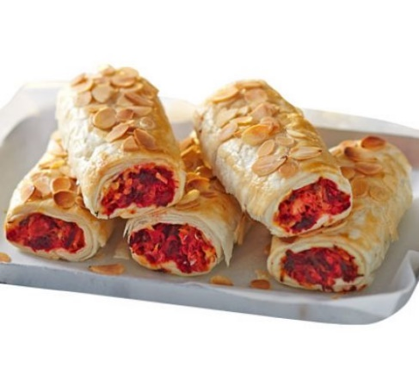
Ingredients
1 tbsp olive or rapeseed oil
1 large onion, halved and grated (kids might need to wear goggles to avoid any tears!)
2 carrots, grated
1 beetroot, grated (wear gloves to avoid pink fingers)
100g mature cheddar, grated
small bunch thyme, leaves picked
50g flaked almonds
320g sheet puff pastry
1 egg, beaten
salad or baked beans, to serve

Method
- Heat the oil in a large pan. Add the onion and sizzle for 5 mins, stirring now and then, until softened. Add the carrot and beetroot, season well and cook gently for 5-10 mins, stirring until the veg is soft. Tip into a bowl.
- Stir the cheese and thyme leaves into the vegetable mixture while it’s still warm. Roughly crumble half the almonds in your hands and add these to the bowl too. Chill the mixture for 30 mins or so until cool enough to handle.
- Unroll the pastry. Cut in half lengthways, then pile the cooled filling down the middle of each strip of pastry. Brush the edges of the pastry with a little beaten egg, then fold the sides over to cover the filling. Turn the rolls over so the pastry seam is tucked underneath and cut each roll into 3, so you have 6. Place on a baking tray lined with baking parchment, brush with a little more egg and sprinkle over the remaining almonds. Chill until ready to cook (or at least 15 mins). Heat oven to 200C/180C fan/gas 6.
- Bake for 20 mins until golden brown. Serve the rolls warm or cold with salad or baked beans.

